Santa Tracker

Santa’s rounds on the firetruck are still a few days away, please join us for the Santa Breakfast just prior on December 14. Details are in our Facebook group and on www.tvfc5.org

This year we are pleased to announce that we will again be using the Santa Tracker.

This software application is provided by Glympse and sponsored by   


To see where Santa is and has been on his firetruck rounds go to the following website on your PC and/or phone:

[**https://glympse.com/!taneytownsanta**](https://glympse.com/!taneytownsanta)   
 **Notice the exclamation point before “taneytownsanta” and there are no spaces**

The application’s “preferred browsers” are **Safari** (the iphone default) & **Chrome**.   
Other browsers should also work but they don’t guarantee that.

Please understand that tracking may be spotty in areas where Verizon coverage is not strong, as always, listen for the sirens and horns

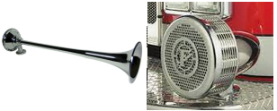

This is our second attempt at using this software, the designers have made some changes that seem   
to work well.

Please give us feedback by replying to this post. Or emailing [PublicRelations@tvfc5.org](mailto:PublicRelations@tvfc5.org)

